

Project 1 Phase 2: Digital game distributor

by

Mr. Waris Dmakham 6388014

Mr. Thanawath Huayhongthong 6388016

Miss Chalumphu Atjarit 6388020

Mr. Naphat Sookjitsumran 6388059

Miss Vipavee Ngamyingsurat 6388094

Mr. Thanakij Pinyoboon 6388097

Submitted to

Asst. Prof. Dr. Thanwadee Sunetnanta

Lect. Dr. Morakot Choetkietikul

Lect. Dr. Chaiyong Ragkhitwetsagul

A Report Submitted in Partial Fulfillment of

the Requirements for

ITCS371 Introduction to Software Engineering

Faculty of Information and Communication Technology

Mahidol University

2022

**Table of Contents**

**Revision of the deliverables presented in the 1st phase and the list of changes with an explanation** 1

**High-level use case diagram** 1

Revision Log of High-level use case diagram 1

**Use case diagram** 2

Revision Log of Use case diagram 2

**Data Flow level. 0** 3

Revision Log of Data Flow diagram level 0 4

**Functional Decomposition Diagram** 6

**Data Flow Diagram Level 1 and 2 of all processes** 7

**Data Flow Diagram level 1** 7

**Data Flow Diagram level 2** 8

**Purchasing process** 8

**Send license game process** 9

**Refund process** 10

**Categorize Process** 11

**Register Process** 12

**Mock-up prototype** 13

**Design Prototype** 13

**Test Cases** 15

**Test Login Process** 15

**Purchasing Process** 16

**Register Process** 17

**Functional Requirement Traceability Matrix** 18

# **Revision of the deliverables presented in the 1st phase and the list of changes with an explanation**

## **High-level use case diagram**

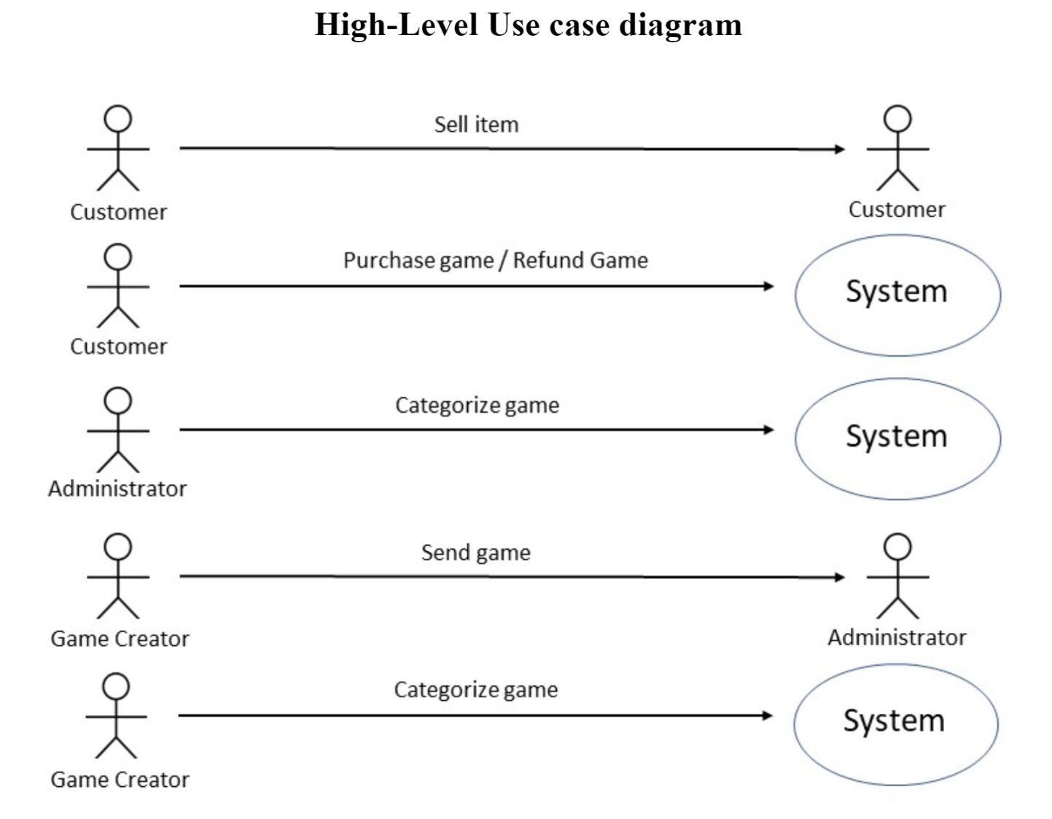

### Revision Log of High-level use case diagram

* We deleted this diagram out of our report because it is not partial to any other diagram in the field of software engineering.

## **Use case diagram**

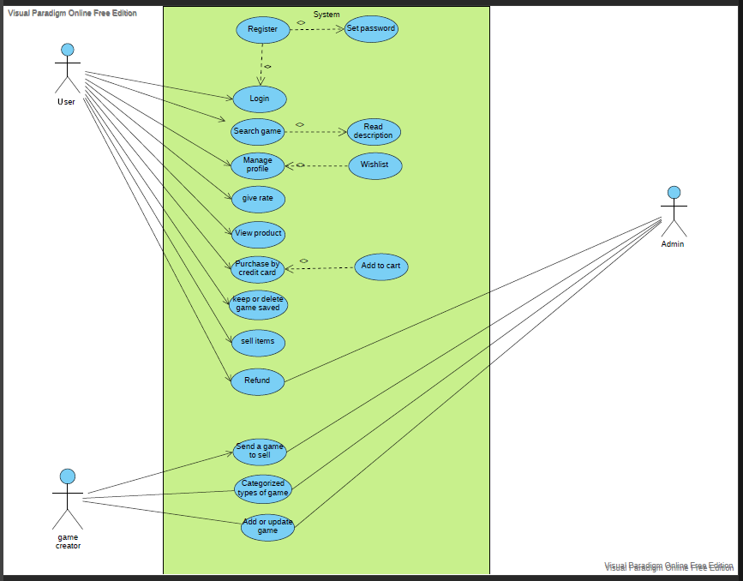

### Revision Log of Use case diagram

* Change the actor's name from "Actor" to "User."

## **Data Flow level. 0**

From this diagram, we must change a lot of things. First, the data flow needs to show

a flow of data, so we decided to redesign our data flow level. 0 is depicted in the diagram below.

### Revision Log of Data Flow diagram level 0

* The blue highlight shows a flow of data, and we edit a new word to be appropriate with a DFD level of 0.
  + Wording between User (Current) and Digital game distributer process
    - **Send license game** to **Game license**
    - **Purchase game** to **Receipt purchase game**
    - **Return money to user wallet** to **Confirm refund form**
    - **Refund Game** to **Refund form request**
  + Wording between User (New) and Digital game distributer process
    - **User information** to **Stored User Information**
    - **Form Register** to **Send Register Confirm**
  + Wording between Game Creator and Digital game distributer process
    - **Send Game** to **Send License Game**
    - **Categorize game** to **Sales report**
  + Wording between Administrator and Digital game distributer process
    - **Update game stock** to **Report game stock**
    - **Write game description** to **Report Game Description**
    - Remove **Categorize game**
    - Remove **Send detail game**
* We made the mistake of making entities have relationships with each other in the first diagram, so we redesign it to separate them.

# **Diagram Description automatically generatedFunctional Decomposition Diagram**

# **Data Flow Diagram Level 1 and 2 of all processes**

**Data Flow Diagram level 1**

Figure 1

## **Data Flow Diagram level 2**

## **Purchasing process**

## **Send license game process**

## **Refund process**

## **Categorize Process**

## **Register Process**

# **Mock-up prototype**

**Design Prototype**

Figure 1

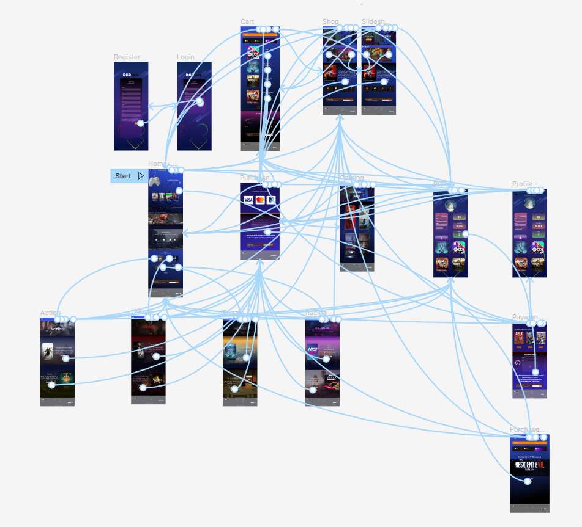

Figure 2

Source: <https://www.figma.com/file/NrTkdcZhaUZrcPVCmYurS8/Digital-game-distributor_Samoyed?node-id=0%3A1&t=bsoZHRD8IW8jEQrj-1>

# **Test Cases**

## **Test Login Process**

Description: Check to see if the login function is operational.

|  |  |  |  |  |
| --- | --- | --- | --- | --- |
| **Test Case ID** | **Specification - Tittle** | **Test Data** | **Step to test** | **Expected Result** |
| SY01 | Test if a user will be able to login with a valid email, password, and verification code. | The user's email, password, and verification code | 1. Input valid email and password to the correct field.  2. Input the valid verification code from the email address you used to register previously.  3. To check the login process, click the Login button. | If the input is valid, the website should go to the homepage. |
| SY02 | Test if a user cannot to login with either invalid email, password, and verification code. | The user's email, password, and verification code | 1. Input invalid email and password to the correct field.  2. Input the invalid verification code from the email address you used to register previously.  3. To check the login process, click the Login button. | If the input is invalid, the website should show “Incorrect email /password/ verification code” and stay at the login page. |

## **Purchasing Process**

Description: Check to see if the Purchasing function is operational.

|  |  |  |  |  |
| --- | --- | --- | --- | --- |
| **Test Case ID** | **Specification - Tittle** | **Test Data** | **Step to test** | **Expected Result** |
| SY03 | Test if a user will be able to purchase with a valid first name, last name, card number, expiration date, and security code. | The user's first name, last name, card number, expiration date, and security code | 1. Input valid first name and last name to the correct field.  2. Input the valid card number, expiration date, and security code into the correct field.  3. To check the payment process, click the Submit button. | If the input is valid, the website will allow you to complete the purchase by clicking "submit." |
| SY04 | Test if a user cannot to purchase with either invalid first name, last name, card number, expiration date, and security code. | The user's first name, last name, card number, expiration date, and security code | 1. Input valid first name and last name to the correct field.  2. Input the invalid card number, expiration date, and security code into the correct field.  3. To check the payment process, click the Submit button. | If the information you put in is wrong, the website won't let you finish the purchase after you click "Submit." |

## **Register Process**

Description: Check to see if the register function is operational

|  |  |  |  |  |
| --- | --- | --- | --- | --- |
| **Test Case ID** | **Specification - Tittle** | **Test Data** | **Step to test** | **Expected Result** |
| SY05 | Test if a user will be able to register with valid information and create an account. | The user's valid information | 1. Input all valid information into required fields. 2. Press the done button. | If all the information is correct, the website will save the user's information to the database, create your account, and send a verification code to your email. |
| SY06 | Check to see if a user can sign up with incorrect information and still create an account. | The user's invalid information | 1. Input invalid information into required fields i.e., wrong email domain. 2. Press the done button. | If all of the information is incorrect, the website will notify the user in the missing or invalid field and allow them to re-enter their information. |

# **Functional Requirement Traceability Matrix**

|  |  |  |  |  |
| --- | --- | --- | --- | --- |
| **Functional Requirements ID** | **Functional Requirements** | **Design (DFD Process)** | **Test** | **Status (Pass/Fail)** |
| FR01 | Users can edit their profiles and personal information. | Process - Register | SY05 and SY06 | Pass |
| FR02 | Users can choose a password with a unique character, uppercase letters, or more than 8 characters. | Process - Register | SY05 and SY06 | Pass |
| FR03 | The customer can make a payment by credit card only. | Process - Purchasing | SY03 and SY04 | Pass |
| FR04 | Users can login to the platform according to their role. | Process – Login | SY01 and SY02 | Pass |